PRACTICAL RESOURCE 5:
Event Programme Template

About this resource
This programme template has been designed for you to edit to suit your event.
You can add, change, and remove any of the symbols and text if you are able
to use “Word” tools.
It has been designed by a professional graphic designer. It is copyright free.
You could use it to produce a leaflet or a poster.
How to use this resource
Photograph or Logo space
- Use the same logo, photograph or other picture you used on your event poster.
- Paste your logo in the box marked logo. Add ALT text.
- If you don’t have a logo, you could copy any other picture or photo in here.
Event title
- Type in the title of your event here.
Date, Time, Venue
- Type in the details next to the symbols.
- Paste a photograph of the front of the venue or use the symbol provided.
Access and Support
- Select the symbols for the things you will provide. Delete the rest.
- Type in brief details here.
Session plan
- Select the symbols for the things you will talk about. Delete the rest.
- Type in the time details next to the symbols.
Co-produced by Communication Inclusion People Community Interest Company (www.communicationinclusionpeople.com)
for Public Health Scotland Place Standard Inclusive Communication Toolkit Project, 2022
Ferry details
Train station details
Parking details
Bus numbers details
Venue address
Start & finish time
Day & date
Photograph or logo here
Event title here
Getting there
Information on food and drinks available
Information on childcare, changing facilities, play area etc., if and how to book it
Information on other communication support here, if and how to book it e.g. communication support staff
Information on visual impairment support
Information on BSL or sign language interpreting, if and how to book it
Information on hearing loop and other hearing support
Information on physical access including changing places, toilets or other toilets for disabled people
Access and support
Session Plan

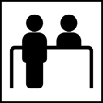
(Time) Arrive
(Time) Tea, coffee

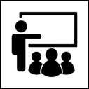
(Time) Start Place Standard Session

1. Welcome and introduction by (name)
2. Think, score, talk and get your ideas about:
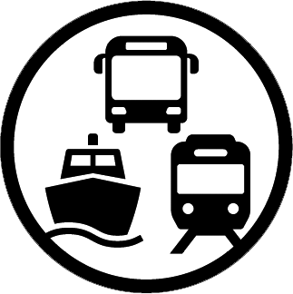
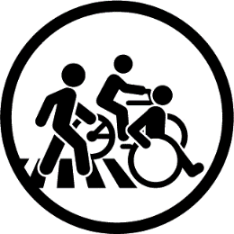
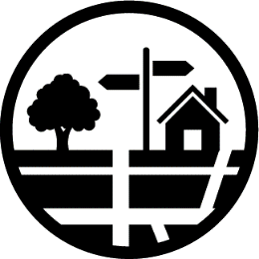
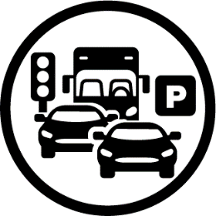
Public transport
Moving around
Streets and spaces
Traffic and parking
(Time) Break
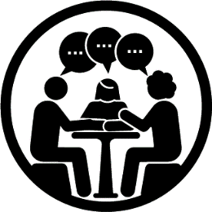
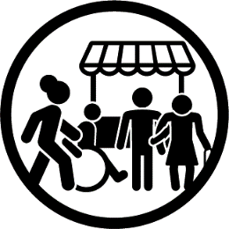
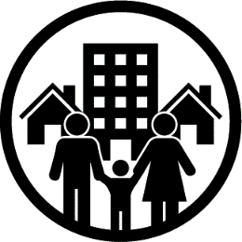
Feeling safe
Social interaction
Identity and belonging
Housing and community

(Time) Lunch
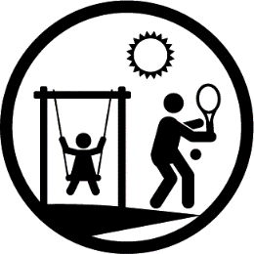
Work and local economy
Natural space
Facilities and services
Play and recreation

3. Finishing speech
- What will happen about your thoughts and ideas
- Your thoughts about the session
- Goodbye

(Time) Finish

