**PRACTICAL RESOURCE 8:**

Photographs for each theme

**About this resource**

Photographs help people start a conversation about the theme.

It is unlikely that any photograph will represent everything in a theme and be equally meaningful to everyone.

The copyright free photographs in this resource represent each theme. They have been selected in consultation with the Place Standard Inclusive Communication Toolkit Co-producers. There are also suggestions for other photographs you could take of your local area.

**How to use this resource**

Copy and paste these symbols into:

* PowerPoint slides
* Practical Resource 10 theme handouts
* Practical Resource 4 posters
* Any written material

You can change the size of the photographs or crop them.

Co-produced by Communication Inclusion People Community Interest Company (www.communicationinclusionpeople.com)  
for Public Health Scotland Place Standard Inclusive Communication Toolkit Project, 2022

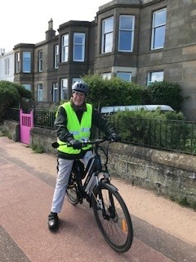

**Moving around**

**Other suggestions for this theme:**

* Paths, pavement, roads, access ramp
* Wheelchair, mobility aids, guide dog
* Pram, pushchair
* Street furniture, bike



**Public transport**

**Other suggestions for this theme:**

* Ferry, ferry terminal
* Bus, bus station
* Cycle rack, cycle storage

Co-produced by Communication Inclusion People Community Interest Company (www.communicationinclusionpeople.com)  
for Public Health Scotland Place Standard Inclusive Communication Toolkit Project, 2022

Co-produced by Communication Inclusion People Community Interest Company (www.communicationinclusionpeople.com)  
for Public Health Scotland Place Standard Inclusive Communication Toolkit Project, 2022

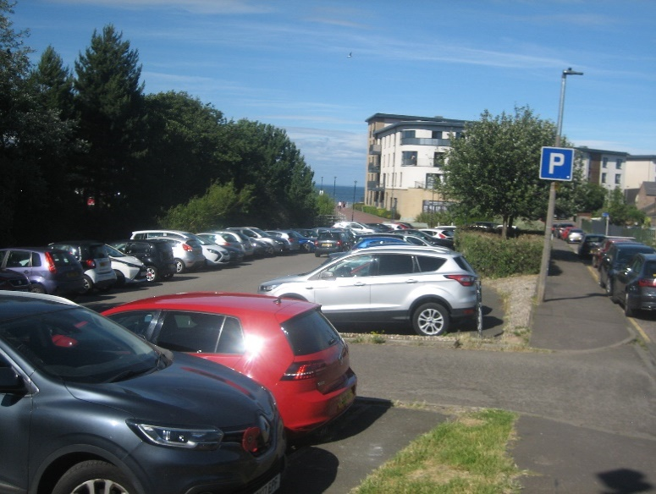**Traffic and parking**

**Other suggestions for this theme:**

* Traffic lights
* Pelican crossing, green man
* Speed sign, parking sign
* Parking ticket machine
* Disabled parking sign
* Car club sign
* Electric charge point

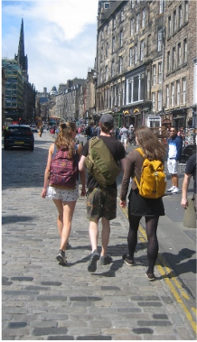

**Streets and spaces**

**Other suggestions for this theme:**

* Street
* Town square
* Local landmark, statue

Co-produced by Communication Inclusion People Community Interest Company (www.communicationinclusionpeople.com)  
for Public Health Scotland Place Standard Inclusive Communication Toolkit Project, 2022

Co-produced by Communication Inclusion People Community Interest Company (www.communicationinclusionpeople.com)  
for Public Health Scotland Place Standard Inclusive Communication Toolkit Project, 2022

**Natural space**

**Other suggestions for this theme:**

* Wild animals, birds
* Parks and woodlands, rivers, canals, beach
* Dog walker

Co-produced by Communication Inclusion People Community Interest Company (www.communicationinclusionpeople.com)  
for Public Health Scotland Place Standard Inclusive Communication Toolkit Project, 2022

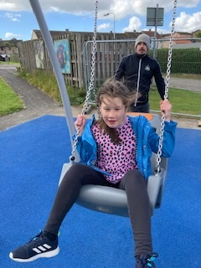**Play and recreation**

**Other suggestions for this theme:**

* Multiuse area with facilities for teenagers, older people
* Adult outdoor gym
* Playground

Co-produced by Communication Inclusion People Community Interest Company (www.communicationinclusionpeople.com)  
for Public Health Scotland Place Standard Inclusive Communication Toolkit Project, 2022

* Sports facilities
* Theatre, arts gallery, library

Co-produced by Communication Inclusion People Community Interest Company (www.communicationinclusionpeople.com)  
for Public Health Scotland Place Standard Inclusive Communication Toolkit Project, 2022

Co-produced by Communication Inclusion People Community Interest Company (www.communicationinclusionpeople.com)  
for Public Health Scotland Place Standard Inclusive Communication Toolkit Project, 2022

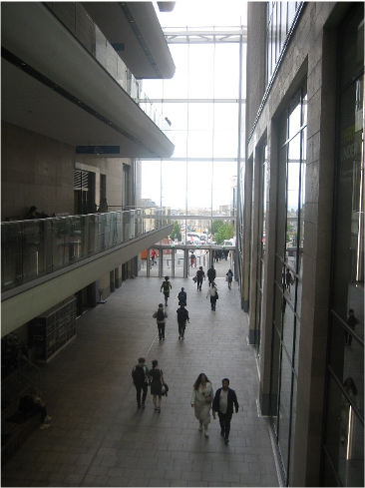

**Facilities and services**

**Other suggestions for this theme:**

* Community hub
* School, college
* Health centre

Co-produced by Communication Inclusion People Community Interest Company (www.communicationinclusionpeople.com)  
for Public Health Scotland Place Standard Inclusive Communication Toolkit Project, 2022

* Recycling

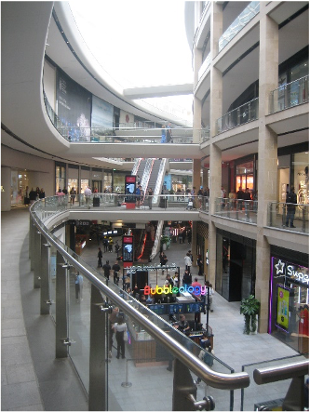

**Work and local economy**

**Other suggestions for this theme:**

* Row of shops
* Local businesses
* Different types of workers

Co-produced by Communication Inclusion People Community Interest Company (www.communicationinclusionpeople.com)  
for Public Health Scotland Place Standard Inclusive Communication Toolkit Project, 2022

Co-produced by Communication Inclusion People Community Interest Company (www.communicationinclusionpeople.com)  
for Public Health Scotland Place Standard Inclusive Communication Toolkit Project, 2022

Co-produced by Communication Inclusion People Community Interest Company (www.communicationinclusionpeople.com)  
for Public Health Scotland Place Standard Inclusive Communication Toolkit Project, 2022

Co-produced by Communication Inclusion People Community Interest Company (www.communicationinclusionpeople.com)  
for Public Health Scotland Place Standard Inclusive Communication Toolkit Project, 2022

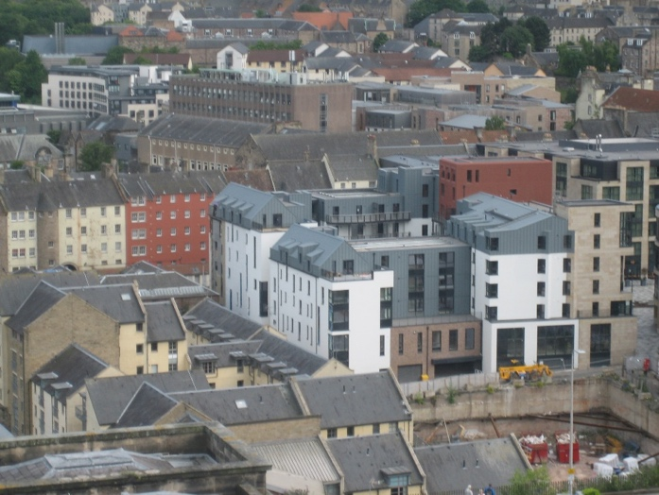

**Housing and community**

**Other suggestions for this theme:**

* Houses, flats, all types of houses

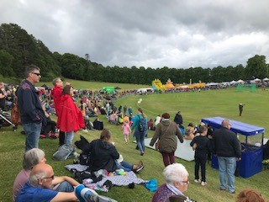

**Social interaction**

**Other suggestions for this theme:**

* People meeting in a street
* People chatting on a street
* People talking in a group or one to one

Co-produced by Communication Inclusion People Community Interest Company (www.communicationinclusionpeople.com)  
for Public Health Scotland Place Standard Inclusive Communication Toolkit Project, 2022

Co-produced by Communication Inclusion People Community Interest Company (www.communicationinclusionpeople.com)  
for Public Health Scotland Place Standard Inclusive Communication Toolkit Project, 2022

Co-produced by Communication Inclusion People Community Interest Company (www.communicationinclusionpeople.com)  
for Public Health Scotland Place Standard Inclusive Communication Toolkit Project, 2022

Co-produced by Communication Inclusion People Community Interest Company (www.communicationinclusionpeople.com)  
for Public Health Scotland Place Standard Inclusive Communication Toolkit Project, 2022



**Identity and belonging**

**Other suggestions for this theme:**

* Community fair, gala day
* Community group smiling in front of a new development

**Feeling safe**

**Other suggestions for this theme:**

* Parent holding a child’s hand
* Police, fire service, ambulance
* Health and safety notices with icons to prevent pollution or accidents

Co-produced by Communication Inclusion People Community Interest Company (www.communicationinclusionpeople.com)  
for Public Health Scotland Place Standard Inclusive Communication Toolkit Project, 2022

Co-produced by Communication Inclusion People Community Interest Company (www.communicationinclusionpeople.com)  
for Public Health Scotland Place Standard Inclusive Communication Toolkit Project, 2022

Co-produced by Communication Inclusion People Community Interest Company (www.communicationinclusionpeople.com)  
for Public Health Scotland Place Standard Inclusive Communication Toolkit Project, 2022

Co-produced by Communication Inclusion People Community Interest Company (www.communicationinclusionpeople.com)  
for Public Health Scotland Place Standard Inclusive Communication Toolkit Project, 2022

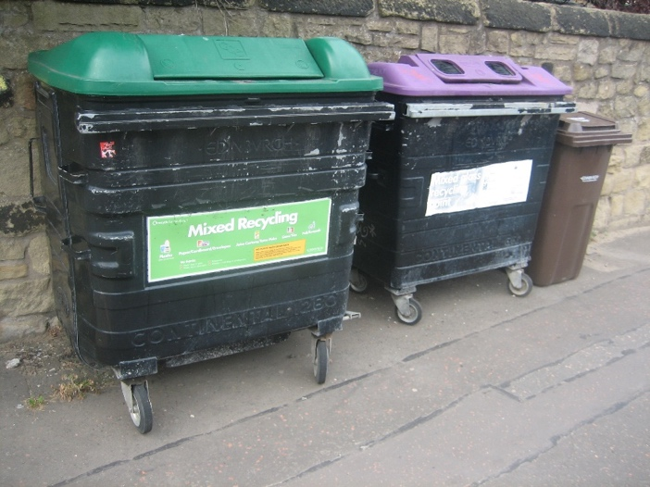

**Care and maintenance**

**Other suggestions for this theme:**

* Refuse lorry
* Bins, anti-litter signs with icons
* Lights and pavements being fixed

**Influence and sense of control**

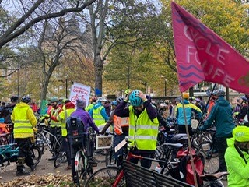**Other suggestions for this theme:**

* Voting box, polling station
* Council chamber, council building
* Public meeting

Co-produced by Communication Inclusion People Community Interest Company (www.communicationinclusionpeople.com)  
for Public Health Scotland Place Standard Inclusive Communication Toolkit Project, 2022

Co-produced by Communication Inclusion People Community Interest Company (www.communicationinclusionpeople.com)  
for Public Health Scotland Place Standard Inclusive Communication Toolkit Project, 2022

Co-produced by Communication Inclusion People Community Interest Company (www.communicationinclusionpeople.com)  
for Public Health Scotland Place Standard Inclusive Communication Toolkit Project, 2022

Co-produced by Communication Inclusion People Community Interest Company (www.communicationinclusionpeople.com)  
for Public Health Scotland Place Standard Inclusive Communication Toolkit Project, 2022