**PRACTICAL RESOURCE 9:**

Symbols for each theme and scoring

**About this resource**

Symbols help people start a conversation about the theme.

No symbol will represent everything in a theme and be equally meaningful to everyone.

The symbols in this resource have been co-designed by a professional graphic designer in consultation with the Place Standard Inclusive Communication Toolkit Co-producers.

The symbols represent each Place Standard Theme and a 3-point scoring scale.

The theme symbols copyright belongs to Public Health Scotland.

The scoring symbols are copyright free.

**How to use this resource**

Copy and paste these symbols into:

* PowerPoint slides
* Practical Resource 10 theme handouts
* Practical Resource 4 posters
* Any written material

You can change the size of the symbols.

Co-produced by Communication Inclusion People Community Interest Company (www.communicationinclusionpeople.com)  
for Public Health Scotland Place Standard Inclusive Communication Toolkit Project, 2022

**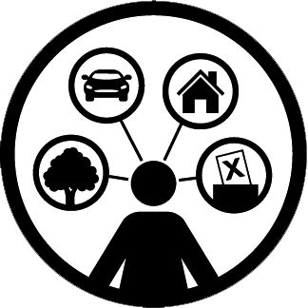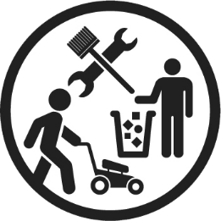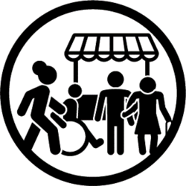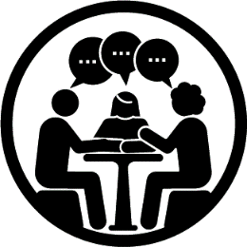******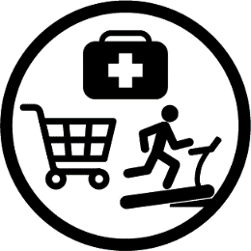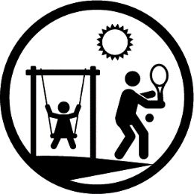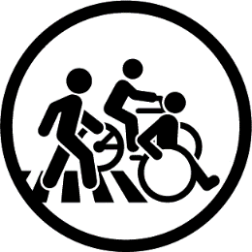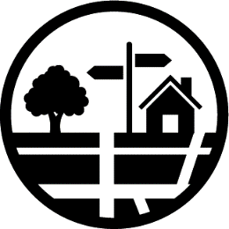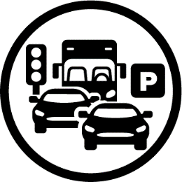

**Housing and community**

**Social interaction**

**Identity and belonging**

**Feeling safe**

**Care and maintenance**

**Facilities and services**

**Play and recreation**

**Natural space**

**Streets and spaces**

**Traffic and parking**

**Public transport**

**Moving around**

Co-produced by Communication Inclusion People Community Interest Company (www.communicationinclusionpeople.com)  
for Public Health Scotland Place Standard Inclusive Communication Toolkit Project, 2022

**Influence and sense of control**

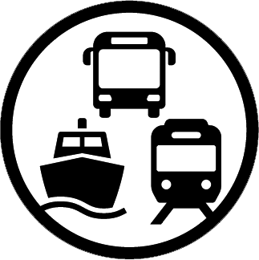

**Work and local economy**

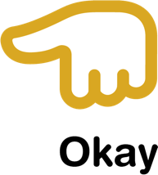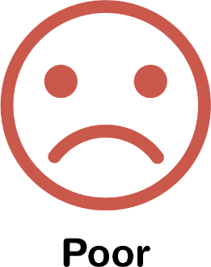**Symbols for scoring**

Co-produced by Communication Inclusion People Community Interest Company (www.communicationinclusionpeople.com)  
for Public Health Scotland Place Standard Inclusive Communication Toolkit Project, 2022