About this resource

PRACTICAL RESOURCE 10:
Theme handouts – all themes
This document provides all 14 Place Standard theme handouts in one document. This might make it easier to print out all the one page theme handouts as a booklet for each participant to take away.
Each handout gives you:

- an inclusive symbol
- inclusive prompt questions
- inclusive 3 point score rating to mark
- space to write or draw or have their views written for them. It is designed for you to edit to suit your needs. It is in “Word”.
It has been designed by a professional graphic designer. It is copyright free.

How to use this resource
Prepare the handouts to meet the needs of your session by:

- adding, changing, or removing text. To keep it simple refer to PRACTICAL RESOURCE 2: Step-by-step communication inclusive writing guidance
- pasting in a photograph instead of using the symbol. See
PRACTICAL RESOURCE 8: Photographs for each theme
Some people may need more space to write their answers. Print out and copy enough handouts for your event.

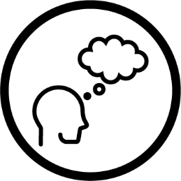
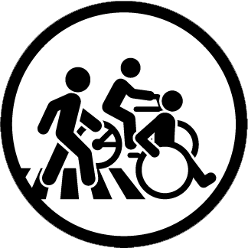Think about

MOVING AROUND
How easy is it to move around?
  - Is it easy to get to places?
  - Is it easy to find information about moving around?
  - Are there enough paths for walking, cycling and wheelchair users?
  - Are the paths pleasant and safe?
Tick your score
POOR ☐ OKAY ☐ GOOD ☐

What is your experience?

What would improve it?

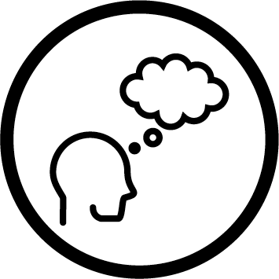
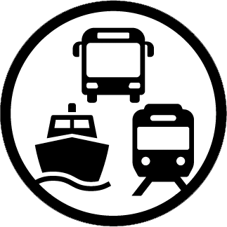Think about

PUBLIC TRANSPORT
Are you happy with public transport?
  - Is it easy to use?
  - Is information about it good?
  - Is the cost of tickets fair?
  - Are bus, train and ferry stations safe?

Tick your score
POOR ☐ OKAY ☐ GOOD ☐

What is your experience?

What would improve it?

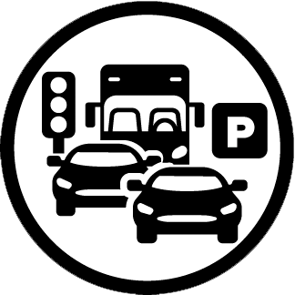Think about

TRAFFIC AND PARKING
Are you happy with how traffic and parking impact on you?
  - Are people or cars given more importance?
  - Is the traffic safe?
  - Is there enough parking?
  - Are there ways to travel which are better for the environment?

Tick your score
POOR ☐ OKAY ☐ GOOD ☐

What is your experience?

What would improve it?

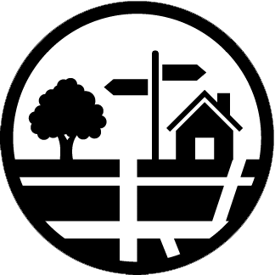Think about

STREETS AND SPACES
Are you happy with buildings, streets and public spaces?
  - Are the streets and public spaces pleasant?
  - Is it easy to find your way around?
  - Can everyone use them?
  - Are there neglected buildings or land?

Tick your score
POOR ☐ OKAY ☐ GOOD ☐

What is your experience?

What would improve it?

Think about

NATURAL SPACES
Are you happy with parks and outside spaces?
  - What kind of natural spaces are there?
  - Are they clean and safe?
  - Can everyone use them?
  - Is there anything that stops people using them?

Tick your score
POOR ☐ OKAY ☐ GOOD ☐

What is your experience?

What would improve it?

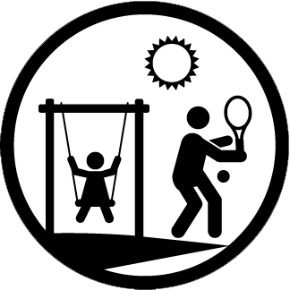Think about

PLAY AND RECREATION
How good are play, sports and leisure facilities?
  - Are there things for all age groups?
  - Are they open to everyone?
  - Are they well used?
  - Is there anything that stops people using them?

Tick your score
POOR ☐ OKAY ☐ GOOD ☐

What is your experience?

What would improve it?

Think about

FACILITIES AND SERVICES
How well do facilities and services meet your needs?
  - What public services and other support are there?
  - Are they easy to get to?
  - Are they easy to use?
  - Is there anything that stops people using them?

Tick your score
POOR ☐ OKAY ☐ GOOD ☐

What is your experience?

What would improve it?

Think about

WORK AND LOCAL ECONOMY
Are there enough places to work, volunteer and train?
  - Are there lots of local businesses?
  - Are there different sorts of paid work and volunteering?
  - Is there support for people who want to work?
  - Are there lots of training opportunities?
  - Is it easy to travel to and from work?

Tick your score
POOR ☐ OKAY ☐ GOOD ☐

What is your experience?

What would improve it?

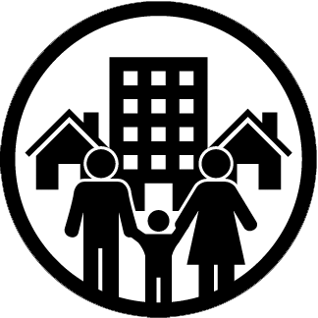Think about

HOUSING AND COMMUNITY
Do the homes in your area meet everyone’s needs?
  - Is there a good mix of housing types?
  - Are areas where people live attractive?
  - Is your place able to adapt to future changes?

Tick your score
POOR ☐ OKAY ☐ GOOD ☐

What is your experience?

What would improve it?

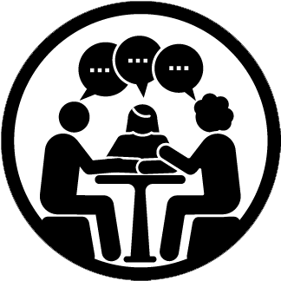Think about

SOCIAL INTERACTION
Are there enough places to meet up with other people?
  - Are they available to people of all ages?
  - Are they pleasant and safe
  - Is there good contact between neighbours?

Tick your score
POOR ☐ OKAY ☐ GOOD ☐

What is your experience?

What would improve it?

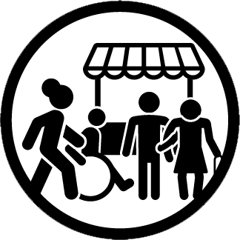Think about

IDENTITY AND BELONGING
Does your area have its own identity, and do you feel part of it?
  - Are you proud of your area?
  - Do you feel part of it?
  - What do other people think about it?

Tick your score
POOR ☐ OKAY ☐ GOOD ☐

What is your experience?

What would improve it?

Think about

FEELING SAFE
Do you feel safe?
  - Do you feel safe outside?
  - Do you feel safe in public places?

Tick your score
POOR ☐ OKAY ☐ GOOD ☐

What is your experience?

What would improve it?

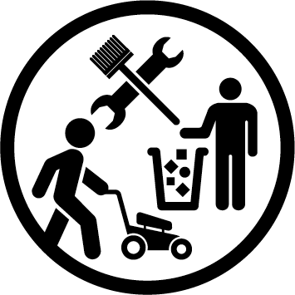Think about

CARE AND MAINTENANCE
Is your neighbourhood clean and tidy?
  - Are the streets clean?
  - Is there any rubbish?
  - Is there dog mess?
  - Are there any empty buildings?

Tick your score
POOR ☐ OKAY ☐ GOOD ☐

What is your experience?

What would improve it?

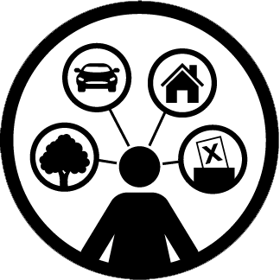Think about

INFLUENCE AND CONTROL
Do people listen to what you say and include you in decision making?
  - Do you know who to go to if you have a problem in your community?
  - Do people listen to what the community says?
  - Is there anything that stops people getting involved in community discussions?
Tick your score
POOR ☐ OKAY ☐ GOOD ☐

What is your experience?

What would improve it?

